Snake-RepairLLaMA
Efficient Semantic Code Repair for Python

FINAL YEAR PROJECT (CS-491)
BS(AI) Fall 2025

Ali Suleman
K22-4060

Ahsan Ali
K22-4036

Muneeb Ur Rehman
K22-4025

Team Name

Supervisor: Muhammad Rafi
Department of Computer Science

FAST-National University of Computer & Emerging Sciences, Karachi.

Abstract
Bug fixing is costly and time-consuming, yet recent advances in Large Language Models (LLMs) show strong potential for spotting bugs in code segment and automatically repairs them by keeping the intent valid. While RepairLLaMA demonstrated efficient fine-tuning for Java, Python remains underexplored despite its widespread use and unique bug patterns. Snake-RepairLLaMA addresses this gap by adapting the RepairLLaMA pipeline for Python, curating a high-quality dataset of 5,000 to 7,000 bug-fix pairs from real open source repositories, and applying Parameter-Efficient Fine-Tuning (LoRA) on both large (CodeLlama-7B-Python) and compact (CodeBERT) models. Our goal is to deliver a reproducible, efficient, and accessible framework for semantic code repair in Python.

Introduction
Fixing bugs is a time-consuming and expensive part of software development. While developers spend a significant amount of time debugging, recent advances in Large Language Models (LLMs) show they can help automate this process. However, the most powerful LLMs are massive, expensive to run, and often require full retraining to specialize in a task like repair, making them impractical for widespread use.
Our project addresses this by focusing on efficiently and specifically teaching an AI model to fix bugs in Python code. We aim to create a system that is both effective and feasible to run without requiring massive computational resources.
What's New: We are adapting the state-of-the-art RepairLLaMA technique (previously proven for Java) for Python and we explore whether compact distilled models can achieve comparable performance, making AI repair accessible on modest hardware

Research Gap
Previous work, like the original RepairLLaMA, has successfully demonstrated the use of efficient fine-tuning (LoRA) for code repair. However, this work was focused primarily on Java. The Python ecosystem, with its different quirks and bug patterns, has not been explored with this efficient method.
The research gap is clear: There is a lack of a reproducible, efficient, and open-source pipeline for semantic code repair in Python using modern Parameter-Efficient Fine-Tuning (PEFT) techniques. Our project aims to fill this gap by providing a complete implementation, a curated dataset, and a rigorous evaluation specifically for Python.

Features and Unique Selling Point

Language Specialization:
We are the first to fully replicate and adapt the RepairLLaMA (LoRA) pipeline for the Python programming language.

Unique Selling Point:
We are the first to combine LoRA-based repair fine-tuning with exploration of smaller distilled code models, showing a trade-off between accuracy and efficiency in Python bug repair

Focus on Efficiency:
We will not only use large models like CodeLlama but also experiment with smaller, distilled models (like CodeBERT) to find the best balance between performance and resource requirements.

A New Dataset:
A key contribution of this work will be the creation and open-sourcing of a curated dataset of real-world Python bug-fix pairs, which is currently lacking in the research community. We intend to a new dataset for Python language, a 5000 to 7000 annotated dataset will be a major contribution from this final year project. We wish to follow standard dataset development strategies to build this dataset.
4. Proposed Solution and Methodology Startup

Our methodology involves building an end-to-end pipeline for code repair.

4.1 Which Models We Are Using

We will experiment with two base models to compare the trade-offs:

Primary Model: CodeLlama-7B-Python (A large, powerful model specialized in code). This will be our main model to compare against the original RepairLLaMA results.

Efficiency Model: microsoft/codebert-base (A smaller, distilled model around 125M parameters, pre-trained on code). This will be our experiment to see if we can achieve good results with a much smaller and faster model.

4.2 Why We Are Using Microsoft/CodeBERT and LoRA
Why CodeBERT?
It's a well-known, robust model that already understands the structure of code. It's significantly smaller than CodeLlama (125M vs. 7B parameters), meaning it's faster and can run on less powerful hardware. This makes it ideal for our exploration into efficiency.
Why LoRA?
LoRA (Low-Rank Adaptation) allows us to fine-tune these models without altering their core weights. Instead, we train tiny "adapter" matrices (often <1% of the original model size). This is cheaper, faster, and prevents catastrophic forgetting (where the model forgets its general code knowledge while learning the repair task).

Tentative Timeline

4.1 Data Collection Phase
We acknowledge that a Java-style dataset of 600k samples does not exist for Python. Instead, we will create a high-quality, focused dataset.
Source:
- We will scrape popular, high-star Python repositories on GitHub (e.g., from the Django, Pandas, Flask ecosystems).
Method:
- Using scripts and the GitHub API, we will identify bug-fix commits by looking for commit messages containing keywords like "fix", "bug", "error", etc. We will then use diff parsing to extract the before (buggy) and after (fixed) versions of individual functions.
Goal:
- We aim to create a dataset of approximately 5,000 - 7,000 high-quality bug-fix pairs. We believe that a smaller, high-quality dataset is sufficient for the efficient LoRA fine-tuning method, as it teaches the model how to repair rather than teaching it Python from scratch.

4.2 Reproduction and Implementation phase

Pilot Training
- Fine-tune a CodeLlama-7B (Python) model with LoRA on a subset (e.g. 500–1,000 examples) to test pipeline. Debug training scripts, adjust hyperparameters (LoRA rank, batch size).
- First working RepairLLaMA-like model for Python. Basic evaluation (on a small held-out set) shows plausible fixes.
Full Training:
- Activities: Expand to full dataset (5,000 pairs). Possibly extend the dataset with more commits if needed. Train until convergence (monitor validation loss). Experiment with LoRA hyperparameters (learning rate, adapter size).
- Outcome: Final fine-tuned RepairLLaMA-Python model. Save model weights.

4.3 Evaluation Phase

Benchmark the model on BugsInPy, HumanEval, MBPP (as described),QuixBugs. Collect metrics (fix rate, pass@k). Compare against baselines (e.g. un-tuned model). Analyze results. Possibly do error analysis on cases where model fails.
Outcome: Evaluation report. Charts of performance. Iteration to improve if needed (e.g. more training epochs).

5. System Architecture
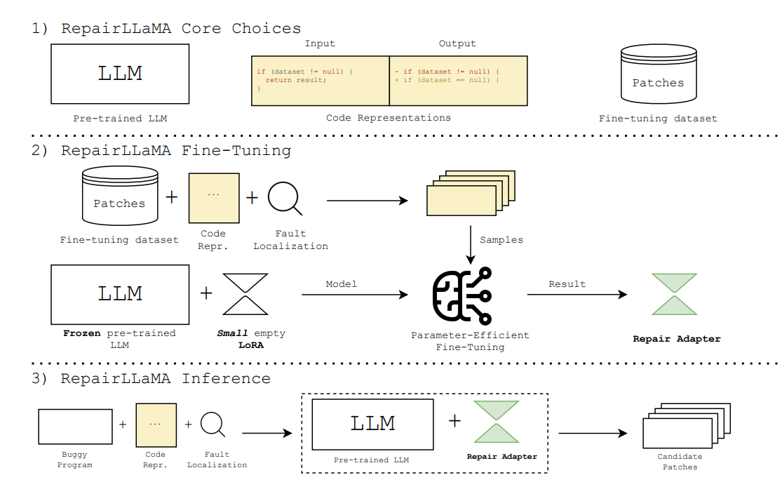
Inference Pipeline:
- Takes a buggy Python function.
- (Optionally) uses a simple fault localization technique to identify suspicious lines.
- Formats the input with the mask token.
- Feeds it into our fine-tuned model to generate multiple candidate fixes.
- Validates the fixes by running tests (from benchmarks).

6. Work Breakdown Structure
FYP - I

Phase | Month | Tasks / Milestones
FYP-1 (4 Months) | Month 1 | - Deep dive into RepairLLaMA paper & repo- Environment setup (PyTorch, HuggingFace, PEFT)- Collect small benchmark datasets (BugsInPy, QuixBugs)
 | Month 2 | - Write scripts for Python bug-fix pair extraction (PyDriller)- Prepare dataset format (buggy → fixed)- Run sanity tests with small dataset
 | Month 3 | - Apply LoRA fine-tuning on CodeLLaMA (Python variant)- Train initial model on small dataset (~500–1000 pairs)- Debug training pipeline
 | Month 4 | - Expand to larger dataset (~5K pairs)- Run RepairLLaMA reproduction experiments- Mid report + 30–40% code ready
Deliverables (FYP-1) | End Month 4 | Mid Report, dataset pipeline, baseline RepairLLaMA-Py results, 30–40% working code

FYP - II

Phase | Month | Tasks / Milestones
FYP-2 (5 Months) | Month 1 (Month 5 overall) | - Literature study on PEFT beyond LoRA- Plan experiments with DistillCodeBERT
 | Month 2 (Month 6 overall) | - Implement LoRA adapters on DistillCodeBERT- Fine-tune DistillCodeBERT on Python bug-fix dataset
 | Month 3 (Month 7 overall) | - Compare RepairLLaMA-Py vs DistillCodeBERT-LoRA- Benchmark on BugsInPy, QuixBugs, HumanEval, MBPP
 | Month 4 (Month 8 overall) | - Error analysis: where models succeed/fail- Optimize training (batch sizes, rank, quantization)
 | Month 5 (Month 9 overall) | - Finalize evaluation- Write final thesis + prepare presentation- Submit final report
Deliverables (FYP-2) | End Month 9 | Final Report, RepairLLaMA-Py model, DistillCodeBERT-LoRA model, Benchmark results, Thesis + Defense

6. PROJECT FEASIBILITY
Technical Feasibility
The project will use Python with PyTorch, Hugging Face Transformers, and LoRA for fine-tuning. All tools are open-source and well supported. Datasets will be prepared using GitHub commit mining (via PyDriller) and existing open datasets like BugsInPy.
Economic Feasibility
No licensing cost is required. Libraries, frameworks, and datasets are free. GPU access can be managed through university labs or free/educational credits, so the project has almost zero direct cost.
Schedule Feasibility
Training may take time depending on dataset size and GPU availability, but within a 7-month timeline the work is feasible. Even if full dataset collection is delayed, smaller subsets can still demonstrate results on time.

7. HARDWARE & SOFTWARE REQUIREMENTS
Hardware
- Intel i7 / AMD Ryzen 7 (or equivalent)
- 16 GB RAM (minimum)
- NVIDIA GPU (RTX 3060–4080, 12–16 GB VRAM)
- ~200 GB storage

Software
- Ubuntu 20.04 / Windows 11
- Python 3.10+ with Anaconda
- PyTorch, Hugging Face Transformers, PEFT (LoRA)
- PyDriller, GitPython (for data mining)
- VS Code / Jupyter Notebook

9. PROJECT DELIVERABLES
- FYP-1 Mid Report
- FYP-1 Final Report
- 30–40% Prototype Code (dataset pipeline + initial LoRA training scripts)

8. FAQ (Anticipated Jury Questions)
Q: What makes this project unique?
A: While others have used large models for code generation, our project is unique in its specific focus on *efficiently* fine-tuning models *specifically for Python bug repair*. Our exploration of using a small, distilled model (CodeBERT) with a LoRA adapter for this task is a novel angle not widely explored.
Q: Is this project feasible for students?
A: Yes, absolutely. We are not building new AI algorithms from scratch. We are using existing, well-documented open-source libraries (Hugging Face, PEFT) to apply proven techniques to a new problem. The computational cost is managed by the incredibly efficient LoRA method, making it possible to run on a single GPU.

Q: The original paper used 600k Java samples. How can your "measly" 5k Python dataset hope to compete?
A: This is a valid point. However, research has shown that with parameter-efficient methods like LoRA, the *quality and focus of data are often more important than sheer quantity. Our 5k samples are not "random" code; they are highly curated, task-specific examples of *bug fixes. This focused learning is what allows the small adapter to become an expert at the repair task, much like a human would learn from a dedicated textbook rather than browsing the entire internet.

10. REFERENCES
A. Silva, S. Fang, and M. Monperrus, “RepairLLaMA: Efficient Representations and Fine-Tuned Adapters for Program Repair,” arXiv preprint arXiv:2502.13012, 2025.
V. Sanh, L. Debut, J. Chaumond, and T. Wolf, “DistilBERT, a distilled version of BERT: smaller, faster, cheaper and lighter,” arXiv preprint arXiv:1910.01108, 2019.
[1] B. Yang, Z. Cai, F. Liu, B. Le, L. Zhang, T. F. Bissyandé, Y. Liu, and H. Tian, “A Survey of LLM-based Automated Program Repair: Taxonomies, Design Paradigms, and Applications,” arXiv preprint arXiv:2401.12345, 2024.

[2] H. Jelodar, M. Meymani, and R. Razavi-Far, “Large Language Models (LLMs) for Source Code Analysis: Applications, Models and Datasets,” arXiv preprint arXiv:2308.98765, 2023.

[3] N. S. Mathews and M. Nagappan, “Test-Driven Development for Code Generation,” in Proc. 31st Int. Conf. Software Engineering and Knowledge Engineering (SEKE), Waterloo, Canada, 2023.

[4] J. A. Prenner and R. Robbes, “RunBugRun: An Executable Dataset for Automated Program Repair,” arXiv preprint arXiv:2309.01234, 2023.

[5] L. Zhang, et al., “Fixing 162 out of 337 Bugs for $0.42 Each using ChatGPT,” in Proc. Int. Symp. Software Testing and Analysis (ISSTA), 2024. [Online]. Available: https://lingming.cs.illinois.edu

[6] R. Shi, Y. Chen, and D. G. Batra, “PyDex: Repairing Bugs in Introductory Python Assignments using LLMs,” in Proc. ACM Conf. Object-Oriented Programming, Systems, Languages, and Applications (OOPSLA), 2024. [Online]. Available: https://cpsc.yale.edu

[7] K. Johnson and M. Kim, “Teaching LLMs to Repair Code via Multi-Objective Fine-Tuning,” in Proc. ACM/IEEE Int. Conf. on Software Engineering (ICSE), 2024. [Online]. Available: https://dl.acm.org

[8] Y. Wang, H. Wang, and L. Zhang, “Demystifying Memorization in LLM-Based Program Repair via a General Hypothesis Testing Framework,” in Proc. ACM Joint European Software Engineering Conf. and Symp. Foundations of Software Engineering (ESEC/FSE), 2025.

[9] P. Kumar and A. Gupta, “Evaluating the Generalizability of LLMs in Automated Program Repair,” in Proc. IEEE/ACM Int. Conf. Software Engineering (ICSE-NIER), 2025, also available as arXiv preprint arXiv:2503.06789.

